  Year 5 | Autumn 1 | Autumn 2 | Spring 1 | Spring 2 | Summer 1 | Summer 2
Visits and Visitors | SCIENCE  National Space Centre Leicester | HISTORY  Burghley House |  | GEOGRAPHY  Lincoln Castle and The Collection |  | HISTORY  History of the Page
Guided Reading  Fiction  Traditional Tales  Non-Fiction  Poetry | -Street Child by Berlie Doherty  - The Princess’ Blankey by Carol Ann Duffy  -Poetry anthology -humorous poetry  - Range of non-fiction texts linked to space and Moon Landing. | -Treason by Berlie Doherty  - If all the world were paper by Joseph Coelho  - Biographies (e.g. famous scientist, significant persons from Tudor period)Extracts from: The people awards by Lily Murray | - The Adventures of Odysseus by Hugh Lupton and Christina Balit  -Narrative poem, e.g. The Highway Man by Alfred Noyes  - Variety of explanation texts eg extracts from Pop, Whizz, Bang magazines including A World of Discovery by James Brown and Richard Platt | -Rooftoopers by Katherine Rundell  -Classic poet (e.g. The Listeners by Walter de la Mare)  - Range of non-fiction books and texts on Vikings to utilise contents/ index  ) | -The Explorer by Katherine Rundell  -Playscripts (use age-appropriate versions e.g. Oxford Reading Tree Dark Blue stages)  - non-fiction book: What a Waste: including key features (e.g subheadings, diagrams, cross sections etc). | - Extracts from:The White Horse of Zenor – Michael Morpurgo.  -The Matchbox Diaries by Paul Fleishman  Range of poetry structured in different ways  -Information extracts inc. diagrams, charts, labelled images
English | Fiction: Alternative ending  Non-fiction- Recount  MOREAPS Poetry linked to Space | Fiction: Character & Setting description  Non-fiction- Biography | Fiction- Cultural story  Non-fiction- Explanation  Poetry- Narrative poem linked to the environment | Fiction- Narrative  Non-fiction- Information texts and non-chronological writing. | Fiction- Adventure story  Non-fiction- Persuasion  Poetry- Tanka Poetry | Fiction- Newspaper Report  Non-fiction- Instructions
Maths  White Rose | 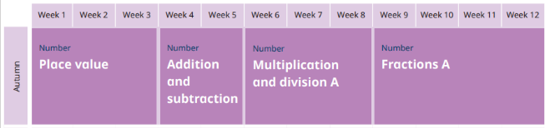 |  | 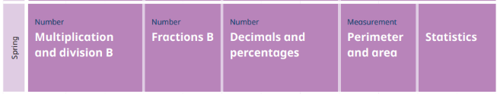 |  | 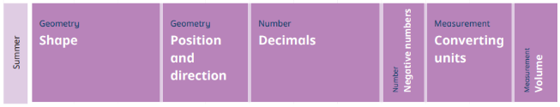
Science | Earth and Space | Forces and Magnets | Materials |  | Animals Including humans | Living Things and Their Habitats
History |  | Tudors |  | Vikings vs Anglo-Saxons |  | Ancient Civilisations- Romans
Geography | South America including Fairtrade |  | Water World |  | Natural resources
DT | Structures  Frame Structures |  | Mechanical Systems  Cams  Moving toys |  | Cooking  Culture and Seasonality
Art |  | Drawing and Sketchbooks  Typography and Maps |  | Paint, Texture and Colour  Inspired by Land and Cityscapes |  | Collaboration and Community  Fashion Design
Music  Charanga | Melody and Harmony in Music:  - Ghost Parade  - Words Can Hurt  - Joyful, Joyful | Sing and Play in Different Styles:  - The Sparkle in My Life  - Dreaming of Mars  - Get on Board | Composing and Chords:  - Freedom is coming  - All Over Again  - Do You Ever Wonder? | Enjoying Musical Styles:  - Erie Canal  - Heroes  - Happy To Be Me | Freedom to Improvise:  - Look Into The Night  - Breathe  - Keeping Time | Battle of the Bands:  - You and Me  - A Bright Sunny Day  - You Belong With Me
Computing | Systems and Networks- sharing information | Creating media  Vector drawings | Creating media  Video editing | Data/Communication- Flat-file databases | Programming A- Selection in physical computing | Programming B- Selection in Quizzes
PSHE  Cambridge Scheme | Myself and My Relationships 14: Beginning and belonging  Citizenship 9: Working together | Citizenship 10: Diversity and communities | Myself and My Relationships 15: My emotions | Healthy and Safer Lifestyles 18: Managing risk  Healthy and Safety Lifestyles 19: Digital lifestyles | Healthy and Safer Lifestyles 21: Healthy Lifestyles | Healthy and Safer Lifestyles 20: Sex and Relationships Education
RE  Lincolnshire scheme | Worship | The True meaning of Christmas | Peace | Forgiveness | Jesus the Healer | Commitment
PE | Indoor: Volleyball | Indoor: Fundamentals | Indoor: Dance | Indoor: Gymnastics | Indoor: games striking and fielding skills | Indoor: Handball
 | Football | Netball | Games: Tag Rugby and Tennis | Fitness: Yoga/ Gym | Outdoor Adventure Activity: Rounders/Cricket | Athletics
MFL  Spanish | Phonics and Seasons | Family | My Home | Weather | Do you have a pet? | Culture – Dia de los muertes

